**DAILY ONLINE ACTIVITIES SUMMARY**

|  |  |  |  |  |  |  |  |
| --- | --- | --- | --- | --- | --- | --- | --- |
| **Date:** | **18-7-2020** | | | | **Name:** | **Harshitha M** | |
| **Sem & Sec** | **8th sem A sec** | | | | **USN:** | **4al16cs038** | |
| **Online Test Summary** | | | | | | | |
| **Subject** | | **No Test** | | | | | |
| **Max. Marks** | |  | | **Score** | |  | |
| **Certification Course Summary** | | | | | | | |
| **Course** | **Machine Learning Foundation** | | | | | | |
| **Certificate Provider** | | | **Great learning academy** | **Duration** | | | **3.0hr** |
| **Coding Challenges** | | | | | | | |
| **Problem Statement:** **1**. **to read the number and compute the series.**  **2. to count the number in th series.**  **3. to check whether number is palindrome or not.**  **4. to find the number between 0 and 50 which are not divisible by 2 and 3.**  **5.micro and array update**  Top of Form | | | | | | | |
| **Status:completed** | | | | | | | |
| **Uploaded the report in Github** | | | | **yes** | | | |
| **If yes Repository name** | | | | **Harshitha-M** | | | |
| **Uploaded the report in slack** | | | | **yes** | | | |

**Online test**

No Test

**Certification course**

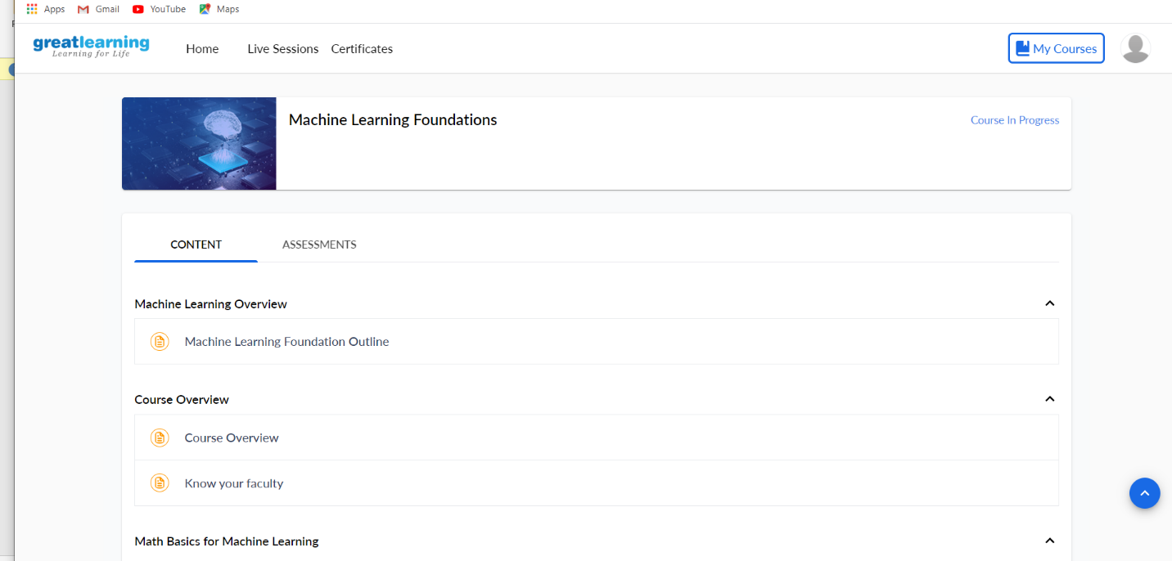

**C Program to check Armstrong number**

#include<stdio.h>

int main()

{

int num,copy_of_num,sum=0,rem;

//Store input number in variable num

printf("\nEnter a number:");

scanf("%d",&num);

/* Value of variable num would change in the

below while loop so we are storing it in

another variable to compare the results

at the end of program

*/

copy_of_num = num;

/* We are adding cubes of every digit

* and storing the sum in variable sum

*/

while (num != 0)

{

rem = num % 10;

sum = sum + (rem*rem*rem);

num = num / 10;

}

/* If sum of cubes of every digit is equal to number

* itself then the number is Armstrong

*/

if(copy_of_num == sum)

printf("\n%d is an Armstrong Number",copy_of_num);

else

printf("\n%d is not an Armstrong Number",copy_of_num);

return(0);

}

**Output:**

Enter a number: 370

370 is an Armstrong Number

You can verify the result like this:

370 = 3*3*3 + 7*7*7 + 0*0*0